SIMATS ENGINEERING
ASSESSMENT TOOL 1

COURSE NAME: INTERNET PROGRAMMING COURSE CODE: CSA4305

COURSE OUTCOME COVERED

CO 3: Implement dynamic web applications by utilizing DOM-based client-side scripting and employing Java Servlets for server-side request processing and response handling. (L3)

Assessment Tool : Scenario-Based Assessment

Weightage: 40%

QUESTIONS: Total Marks: 30

Question 1
Suppose that a college wants to develop an online student registration system where students submit their details through a web form, and the data is processed using a Java Servlet.
Explain the architecture of a servlet-based application. Design and implement a servlet to handle form data using both GET and POST methods. Describe the servlet life cycle (init, service, destroy) and justify which method is more appropriate for handling sensitive data.

Question 2
Suppose that a website requires users to log in and maintain their session across multiple pages after authentication.
Design a session management system using HttpSession and Cookies in Servlets. Explain how session tracking works in web applications and compare session-based tracking with cookies.

Question 3
Suppose that an e-commerce platform needs to store and retrieve product details from a database using a Java-based web application.
Design a JDBC- based application to connect to a database, insert product data, and retrieve it using SQL queries. Explain the JDBC architecture and describe the steps involved in database connectivity along with proper exception handling.

Code of Conduct:

I (B.Vishnu vardhan /192311267) certify that this submission is my original work and that I have adhered to the guidelines specified for this assessment.
I understand that any violation of academic integrity rules will result in disciplinary action.

Signature of the student:


RUBRICS FOR CALCULATION:

Criteria | Weightage (%) | Level 4 (Exemplary) | Level 3 (Proficient) | Level 2 (Developing) | Level 1 (Beginning)
Understanding of Scenario | 20% | Demonstrates clear and complete  understanding of the scenario and context | Shows good understanding with minor gaps | Partial understanding;  misses key aspects | Misinterprets or fails to  understand the scenario
Identification of Key Issues | 20% | Accurately identifies all relevant issues and factors involved | Identifies most key issues with minor omissions | Identifies limited issues; some irrelevant points | Unable to identify key issues
Application of Concepts | 25% | Applies appropriate concepts effectively to address the scenario | Applies concepts with minor errors | Limited or partially correct application | Unable to apply relevant concepts
Decision Making | 20% | Makes well-reasoned, logical decisions with strong rationale | Makes reasonable decisions with  some justification | Makes weak decisions with limited justification | No clear decisions made or  rationale provided
Clarity of Response | 15% | Response is clear, structured, and logically presented | Generally clear with minor issues | Somewhat unclear or  poorly structured | Disorganized and difficult to understand

1: Servlet-Based Student Registration System Architecture of a Servlet-Based Application

Client (Browser)
│ HTTP Request (GET/POST)
▼
Web Server / Servlet Container (e.g., Apache Tomcat)
│ 1. Reads web.xml / annotations to map URL → Servlet
│ 2. Creates request/response objects
▼
Servlet (Business Logic Layer)
│ Processes form data, validates input
▼
Model / DAO Layer (optional, talks to DB via JDBC)
▼
Response generated (HTML / JSON) sent back to Client

Key components:
- Client: Browser submits the registration form.
  - Servlet Container: Manages servlet lifecycle, threading, request dispatching (Tomcat, Jetty).
  - Servlet: A Java class extending HttpServlet that intercepts requests via
doGet()/doPost().
  - web.xml / @WebServlet annotation: Maps a URL pattern to a servlet class.
  - Deployment Descriptor: Configures servlet mappings, session timeout, filters.
This follows the Model-View-Controller pattern loosely — Servlet acts as Controller, JSP/HTML as View, and JavaBeans/DAO as Model.

Servlet Implementation — Student Registration Form

registration.html
<!DOCTYPE html>
<html>
<body>
<h2>Student Registration</h2>
<form action="register" method="post">
Name: <input type="text" name="name" required><br> Email: <input type="email" name="email" required><br> Course: <input type="text" name="course" required><br>
<input type="submit" value="Register">
</form>
</body>
</html>
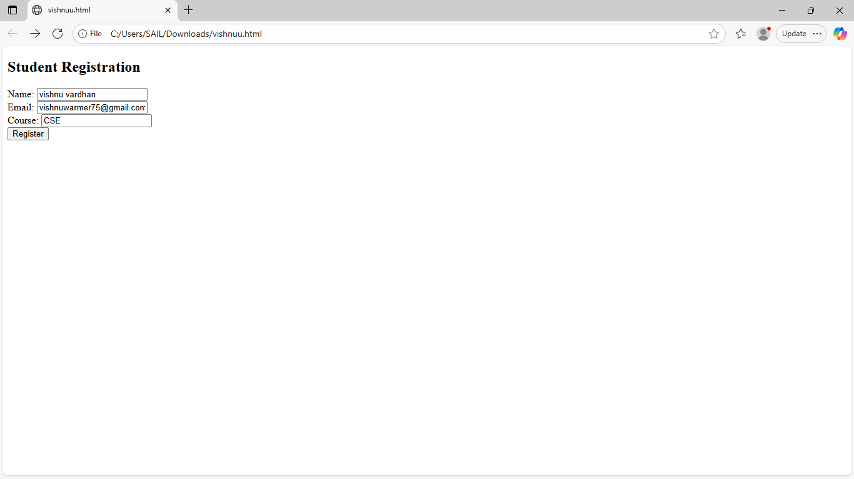

RegistrationServlet.java

import java.io.*;
import jakarta.servlet.*; import jakarta.servlet.http.*;
import jakarta.servlet.annotation.WebServlet;

@WebServlet("/register")
public class RegistrationServlet extends HttpServlet {

// Called once when servlet is loaded @Override
public void init() throws ServletException { System.out.println("RegistrationServlet initialized");
// Ideal place to initialize DB connection pool, config, etc.
}

// Handles GET requests (e.g., pre-filling a form, search by roll no.) @Override
protected void doGet(HttpServletRequest request, HttpServletResponse response)
throws ServletException, IOException { response.setContentType("text/html"); PrintWriter out = response.getWriter();
out.println("<h3>Please use the registration form to submit your details (POST).</h3>");
}

// Handles POST requests (actual form submission) @Override
protected void doPost(HttpServletRequest request, HttpServletResponse response)
throws ServletException, IOException {

// Read form parameters
String name = request.getParameter("name"); String email = request.getParameter("email"); String course = request.getParameter("course");

// Basic validation
if (name == null || name.trim().isEmpty()) { response.sendError(HttpServletResponse.SC_BAD_REQUEST, "Name is
required");
return;
}

// In real app: call DAO layer to insert into DB (see Q3)
response.setContentType("text/html"); PrintWriter out = response.getWriter(); out.println("<h3>Registration Successful</h3>"); out.println("<p>Name: " + name + "</p>"); out.println("<p>Email: " + email + "</p>"); out.println("<p>Course: " + course + "</p>");
}

// Called once when servlet is being removed from service @Override
public void destroy() {
System.out.println("RegistrationServlet destroyed - cleanup resources here");
}
}

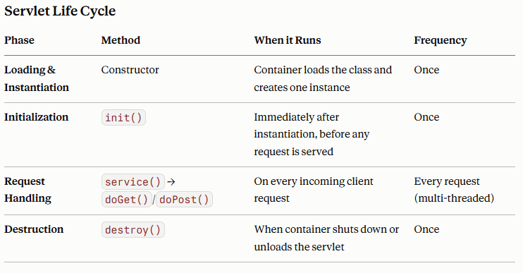

The container creates a single servlet instance and spawns a new thread per request, calling service() on that shared instance — so instance variables must be handled carefully (avoid storing per-request state as instance fields).

  - service() internally dispatches to doGet(), doPost(), doPut(), doDelete(), etc., based on the HTTP method.

GET vs POST for Sensitive Data
POST is more appropriate for sensitive data (e.g., passwords, personal identification, payment info) because:
- Data visibility: GET appends parameters to the URL (?name=John&email=...), which gets logged in browser history, proxy logs, and server access logs. POST sends data in the request body, which is not exposed in the URL.
- URL length limits: GET has practical length restrictions (~2048 characters depending on browser), unsuitable for larger form payloads.
- Caching: GET requests can be cached by browsers/proxies, potentially exposing sensitive data; POST requests are not cached by default.
- Bookmarking/sharing risk: URLs with GET parameters can be accidentally bookmarked or shared, leaking data.
- Idempotency semantics: GET is meant for retrieval (safe, idempotent, no side
effects), while POST is meant for actions that change server state (like creating a registration record) — using POST also aligns with correct REST semantics.
Note: POST alone doesn't guarantee security (data is still plaintext unless HTTPS is used)
— POST + HTTPS + server-side validation/sanitization is the correct combination for handling sensitive registration data.

Question 2: Session Management with HttpSession and Cookies

How Session Tracking Works
HTTP is a stateless protocol — each request is independent and the server has no memory of previous requests by default. Session tracking is the mechanism used to associate a series of requests from the same client into a logical "session," typically achieved through:
- Cookies – server sends a small piece of data to the browser, which the browser returns on every subsequent request.
- URL Rewriting – session ID appended to every URL (used when cookies are
disabled).
- Hidden Form Fields – session ID embedded in hidden form inputs.
- HttpSession API – built on top of cookies (or URL rewriting), servlet containers provide a high-level abstraction (JSESSIONID).

Flow with HttpSession
- User submits login credentials (POST /login)
- Servlet validates credentials
- Servlet calls request.getSession() → container creates a new HttpSession and generates a unique session ID
- Container sends this ID to browser as a cookie: JSESSIONID=ABC123
- Browser stores the cookie and sends it automatically on every request to the same domain
- Servlet retrieves session via request.getSession(false) on each page and reads/writes user-specific attributes

Implementation

LoginServlet.java
@WebServlet("/login")
public class LoginServlet extends HttpServlet {

protected void doPost(HttpServletRequest request, HttpServletResponse response) throws ServletException, IOException {

String username = request.getParameter("username"); String password = request.getParameter("password");

// Simplified authentication check (use DAO + hashed passwords in production) if (isValidUser(username, password)) {

// Create session (true = create if not exists) HttpSession session = request.getSession(true); session.setAttribute("username", username); session.setAttribute("loginTime", new java.util.Date());
session.setMaxInactiveInterval(30 * 60); // 30 minutes timeout

// Optionally set a persistent cookie for "remember me"
Cookie rememberCookie = new Cookie("lastUser", username); rememberCookie.setMaxAge(7 * 24 * 60 * 60); // 7 days rememberCookie.setHttpOnly(true); // not accessible via JavaScript response.addCookie(rememberCookie);

response.sendRedirect("dashboard");
} else {
response.sendRedirect("login.html?error=true");
}
}
private boolean isValidUser(String u, String p) {
// Placeholder — replace with DB check via JDBC return "student".equals(u) && "pass123".equals(p);
}
}

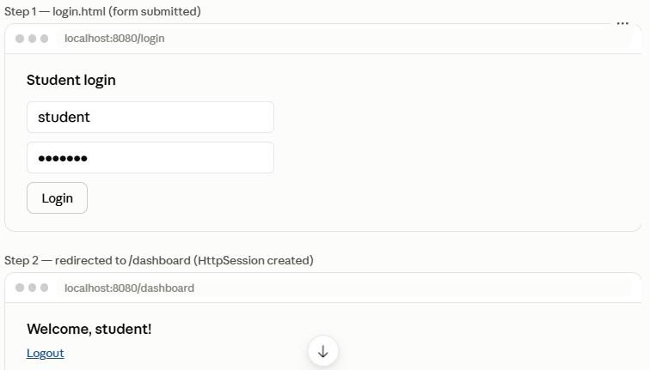
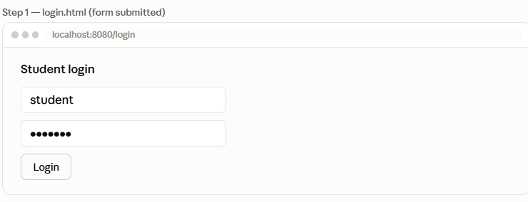
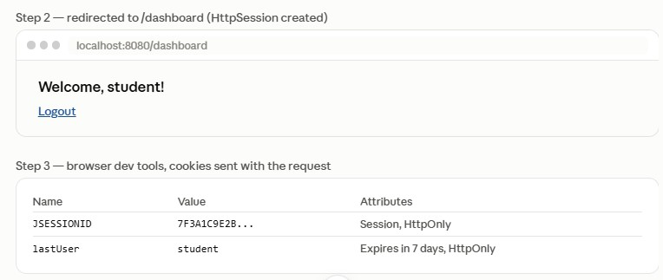

DashboardServlet.java (protected page checking session) @WebServlet("/dashboard")
public class DashboardServlet extends HttpServlet {
protected void doGet(HttpServletRequest request, HttpServletResponse response) throws ServletException, IOException {

HttpSession session = request.getSession(false); // don't create new session

if (session == null || session.getAttribute("username") == null) { response.sendRedirect("login.html"); // not authenticated return;
}

String username = (String) session.getAttribute("username"); response.setContentType("text/html");
PrintWriter out = response.getWriter(); out.println("<h3>Welcome, " + username + "!</h3>"); out.println("<a href='logout'>Logout</a>");
}
}

LogoutServlet.java @WebServlet("/logout")
public class LogoutServlet extends HttpServlet {
protected void doGet(HttpServletRequest request, HttpServletResponse response) throws ServletException, IOException {
HttpSession session = request.getSession(false); if (session != null) {
session.invalidate(); // destroys session and all attributes
}
response.sendRedirect("login.html");
}
}

Aspect | HttpSession | Cookies
Storage location | Server-side (session data lives in server memory/store) | Client-side (stored in browser)
Data sent over network | Only session ID (JSESSIONID) is transmitted | Full cookie data is transmitted with every request
Security | More secure — sensitive data never leaves the server | Less secure — data visible/editable on client unless encrypted
Capacity | Can hold large/complex objects (limited by server memory) | Limited to ~4KB per cookie
Lifetime control | setMaxInactiveInterval(), invalidated on  session.invalidate() or timeout | setMaxAge() — persists even after browser closes if positive value set
Dependency | Internally relies on a cookie (JSESSIONID) or URL rewriting to identify the session | Self-contained, no server-side storage needed
Use case | Storing login state, shopping cart, user preferences during active use | "Remember me" tokens, tracking preferences across visits, lightweight non-sensitive data
Scalability concern | Session replication needed in clustered/load-balanced environments | No such issue since data resides on client

Best practice: Use HttpSession for authentication state and sensitive data; use Cookies
only for non-sensitive, longer-lived preferences (and always mark sensitive cookies HttpOnly
+ Secure).

3: JDBC-Based Product Management for E-Commerce

JDBC Architecture
JDBC (Java Database Connectivity) provides a standard API for Java applications to interact with relational databases, using a driver-based architecture:
Java Application
│ uses JDBC API (java.sql / javax.sql)
▼
DriverManager ──────────────► JDBC Driver (e.g., MySQL Connector/J)
│ │
│ obtains Connection │ translates JDBC calls into
▼ │ DB-specific protocol
Connection ─── Statement/PreparedStatement ─── ResultSet
│
▼
Database (MySQL, PostgreSQL, Oracle, etc.)

Core components:
- DriverManager: Manages a list of database drivers and establishes connections.
  - Driver: Vendor-specific implementation that communicates with the actual database (Type 4 drivers are pure-Java, most common today).
  - Connection: Represents a session with the database.
  - Statement / PreparedStatement / CallableStatement: Used to execute SQL queries.
  - ResultSet: Holds tabular data returned by a query.
  - SQLException: Handles database access errors.

Steps in Database Connectivity
- Load/register the driver (auto-loaded via JDBC 4.0+ SPI, but can be explicit).
- Establish a connection using DriverManager.getConnection(url, user, password).

Create a Statement/PreparedStatement.
- Execute the SQL query (executeUpdate() for INSERT/UPDATE/DELETE,
executeQuery() for SELECT).
- Process the ResultSet (for SELECT queries).
- Close resources (Connection, Statement, ResultSet) — ideally via try-with-resources.
- Handle exceptions using try-catch around SQLException.

Implementation

Database table (MySQL):
CREATE TABLE products (
product_id INT AUTO_INCREMENT PRIMARY KEY, name VARCHAR(100) NOT NULL,
price DECIMAL(10,2) NOT NULL,
stock INT NOT NULL
);

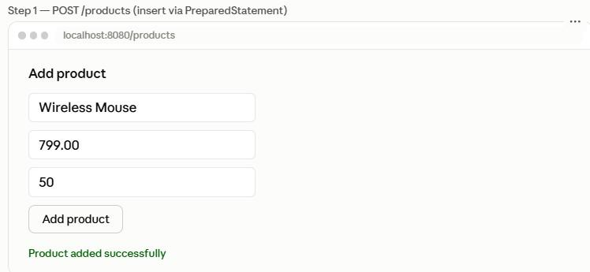

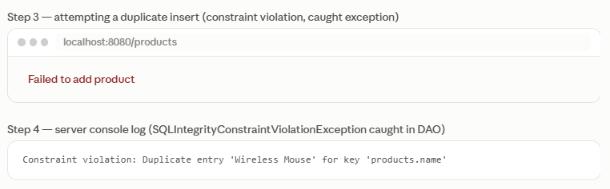

DBConnection.java — Connection utility

import java.sql.*;

public class DBConnection {
private static final String URL = "jdbc:mysql://localhost:3306/ecommerce_db";
private static final String USER = "root";
private static final String PASSWORD = "yourpassword";

public static Connection getConnection() throws SQLException {
// Driver auto-registered via JDBC 4.0+ ServiceLoader mechanism return DriverManager.getConnection(URL, USER, PASSWORD);
}
}

ProductDAO.java — Insert and retrieve using PreparedStatement (prevents SQL injection)

import java.sql.*; import java.util.*;

public class ProductDAO {

// Insert product
public boolean addProduct(String name, double price, int stock) {
String sql = "INSERT INTO products (name, price, stock) VALUES (?, ?, ?)";

try (Connection conn = DBConnection.getConnection(); PreparedStatement pstmt = conn.prepareStatement(sql)) {

pstmt.setString(1, name); pstmt.setDouble(2, price); pstmt.setInt(3, stock);

int rowsAffected = pstmt.executeUpdate(); return rowsAffected > 0;

} catch (SQLIntegrityConstraintViolationException e) { System.err.println("Constraint violation: " + e.getMessage()); return false;
} catch (SQLException e) {
System.err.println("Database error while inserting product: " + e.getMessage()); return false;
}
}

// Retrieve all products
public List<Product> getAllProducts() { List<Product> products = new ArrayList<>();
String sql = "SELECT product_id, name, price, stock FROM products";

try (Connection conn = DBConnection.getConnection(); PreparedStatement pstmt = conn.prepareStatement(sql); ResultSet rs = pstmt.executeQuery()) {

while (rs.next()) {
Product p = new Product( rs.getInt("product_id"), rs.getString("name"), rs.getDouble("price"), rs.getInt("stock")
);
products.add(p);
}

} catch (SQLException e) {
System.err.println("Database error while fetching products: " + e.getMessage());
}
return products;
}

// Retrieve single product by ID
public Product getProductById(int id) {
String sql = "SELECT product_id, name, price, stock FROM products WHERE product_id = ?";
Product product = null;

try (Connection conn = DBConnection.getConnection(); PreparedStatement pstmt = conn.prepareStatement(sql)) {

pstmt.setInt(1, id);

try (ResultSet rs = pstmt.executeQuery()) { if (rs.next()) {
product = new Product( rs.getInt("product_id"), rs.getString("name"), rs.getDouble("price"), rs.getInt("stock")
);
}
}

} catch (SQLException e) {
System.err.println("Error fetching product ID " + id + ": " + e.getMessage());
}
return product;
}
}

Product.java — Model class

public class Product { private int id; private String name;
private double price; private int stock;

public Product(int id, String name, double price, int stock) { this.id = id;
this.name = name; this.price = price; this.stock = stock;
}
// getters and setters omitted for brevity @Override
public String toString() {
return "Product{id=" + id + ", name='" + name + "', price=" + price + ", stock=" + stock +
"}";
}
}

ProductServlet.java — Wiring JDBC into the servlet layer

@WebServlet("/products")
public class ProductServlet extends HttpServlet {
private ProductDAO productDAO = new ProductDAO();

protected void doPost(HttpServletRequest request, HttpServletResponse response) throws ServletException, IOException {
String name = request.getParameter("name");
double price = Double.parseDouble(request.getParameter("price")); int stock = Integer.parseInt(request.getParameter("stock"));

boolean success = productDAO.addProduct(name, price, stock);

response.setContentType("text/html"); PrintWriter out = response.getWriter();
out.println(success ? "<p>Product added successfully</p>" : "<p>Failed to add product</p>");
}
protected void doGet(HttpServletRequest request, HttpServletResponse response) throws ServletException, IOException {
List<Product> products = productDAO.getAllProducts(); response.setContentType("text/html");
PrintWriter out = response.getWriter();
out.println("<table border='1'><tr><th>ID</th><th>Name</th><th>Price</th><th>Stock</th></tr>");
for (Product p : products) {
out.println("<tr><td>" + p.getId() + "</td><td>" + p.getName() + "</td><td>" + p.getPrice() + "</td><td>" + p.getStock() + "</td></tr>");
}
out.println("</table>");
}
}

Exception Handling Best Practices
- Use try-with-resources for Connection, Statement, and ResultSet — ensures they're closed automatically even if an exception occurs, preventing connection leaks.
- Catch specific exceptions before generic ones — e.g., SQLIntegrityConstraintViolationException (duplicate keys, null constraint violations) before generic SQLException.
- Never expose raw SQL error messages to the end user — log them server-side
and show a generic message to the client (avoids leaking schema details — a security concern).
- Always use PreparedStatement instead of Statement with concatenated strings — prevents SQL injection, since parameters are bound safely rather than interpolated into the query text.
- Use connection pooling (e.g., HikariCP, Apache DBCP) in production instead of opening a new DriverManager connection per request — raw DriverManager.getConnection() per request is expensive and doesn't scale well under load.
- Roll back transactions on failure when performing multiple related writes (e.g., conn.setAutoCommit(false), then conn.rollback() in the catch block) to maintain data consistency for multi-step operations like order placement with inventory deduction.

